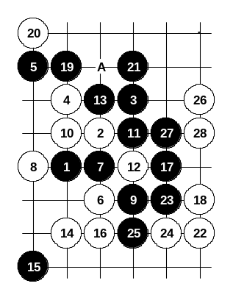
One more 11th move. Although active, it is very bad move. From move 14 white begins winning attack. If 21-A then 3x3 at point 27.

Diagram i1-72
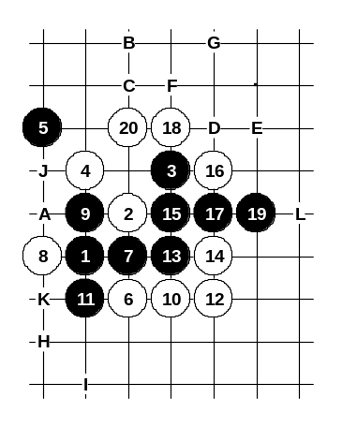
Conclusion about this 9th move: Despite the possible black activity at the beginning, all the variants end with black’s total failure.

Diagram i1-73

Another 9th move. Black chooses passive plan here. Move 9-9 is strong in the meaning of defense, but in global view, black will be surrounded and the outcome is the disaster anyway. By the 20th move white advantage is too big. Making that advantage to become a victory is just the matter of time. If 21-A then white’s winning attack begins with 22-B, 23-C, 24-D, 25-E, 26-F.
If 21-C then the simplest winning plan is 22-F, 23-G (must), 24-H, 25-A, 26-I (.. if 25-J then 26-K). The point L is also very useful for white in many cases.
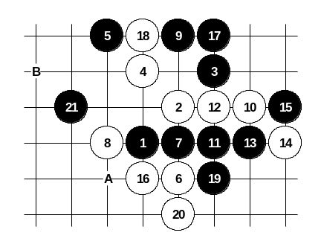
Move 12-13 is not that good because of 13-12. Move 12-H is very questionable because of 13-20. Conclusion about this 9th move: In case of best 12th move (12-12) black position will collapse soon and white will win.

Another 9th move. From move 10 white gets the initiative, but at move 16 it is not easy to decide what is the best continuation for white. After 16-16 the position becomes a chaos – the outcome of this variant is not clear, white is aggressive in lower area, black is aggressive in upper area. Black can also use more passive style: 17-20, 18-19, 19-A, 20-B, 21-21.

Diagram i1-74
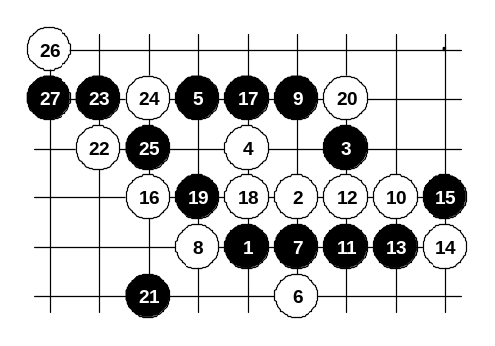

Diagram i1-75
This 16th move is perhaps the most interesting as well as the strongest. From move 17 black is free to attack but everything is still under white’s control. Black aggressive play (17-20, 18-17) makes white’s goal even easier.
“Defensive attack” is probably the best solution for black, as it is shown on the diagram. Indeed, white advantage is very clear there, too.
Move 12-13 is also possible, but it is hard to give any solid opinion there.
Conclusion about this 9th move: Although white must defend carefully here, it is still quite easy to prove white’s sure advantage.
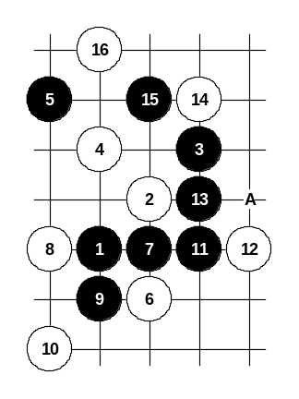
Another 9th move. Here black tries actively to break connections between white stones 6 and 8, but with move 10-10 white keeps the connection alive. Black’s further moves are an attempt to take the key points on the board but by 16th move black is surrounded. Also possible 10-13, 11-A.

Diagram i1-76
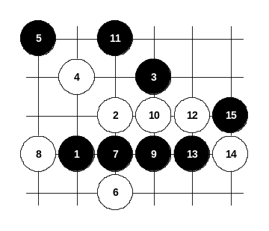
Conclusion about this 9th move: White gets good advantage here without difficulties and without having any need to calculate black’s possible counter-attack.

Diagram i1-77

Another 9th move. Move 11-11 is the only way how black can continue any reasonable development.
By the 15th move the position becomes identical with diagrams i1-74 ~ i1-75.
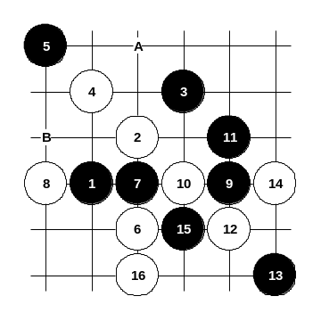

Diagram i1-78
Another 9th move. White cuts black’s development with 10-10 and immediately takes over the initiative. Also possible 14-A, 15-B.
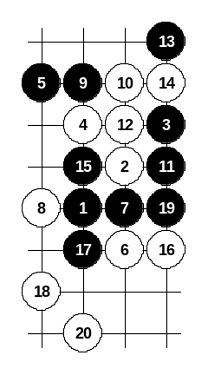
Conclusion about this 9th move: Black is unable to connect its stones, therefore white can easily control the game here. White advantage is very obvious.

Diagram i1-79

Another 9th move. Black tries to gamble with active 11th move. White chooses simple 12-12. Perhaps 13-13 is not very good because by 20th move white practically wins.

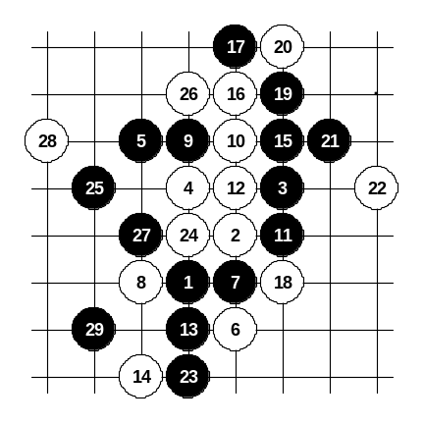

Diagram i1-80

This 13th move is stronger than 13-19. Black uses the attacking material for filling up the space and taking all the important key points.

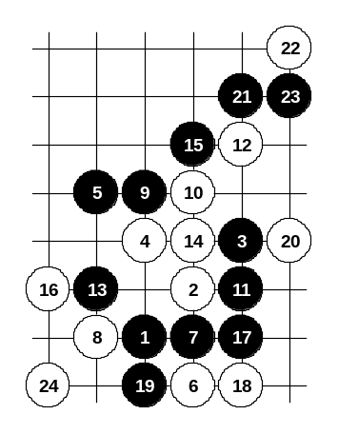
This 12th move is better than 12-14 because now black cannot connect the left and right side. As a result, move 11-11 seems not effective.

Diagram i1-81
Although white can control the lower side space and structures, white must still be careful about black’s left and upper side material and develop in flexible way.
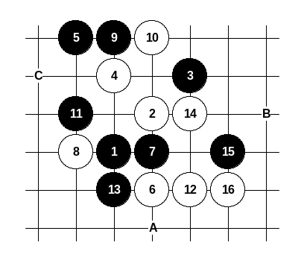

Diagram i1-82
Another 11th move. Black uses passive style here and tries to defend by blocking the white key points. Move 12-12 – one of the possibilities. White can keep the advantage easily here. If 13-16 then 14-15, 15-A, 16-B.
No matter how white attacks, white must be careful about not losing the tempo, because otherwise black can play into power point C and then black could most probably win.
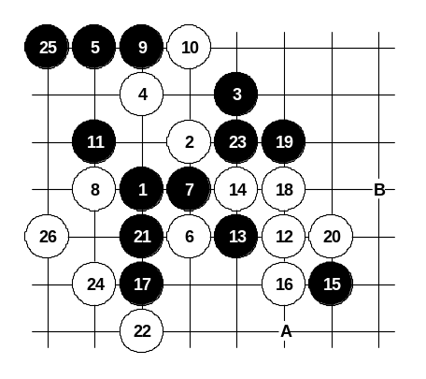

Diagram i1-83
This 12th move is very interesting. White does not give black much choice here. Move 25-25 is a hopeless attempt for counter-attack but it fails after beautiful 26-26.
If 21-A then point 21 becomes a 3x3. Perhaps 21-B gives black some small chance to defend.
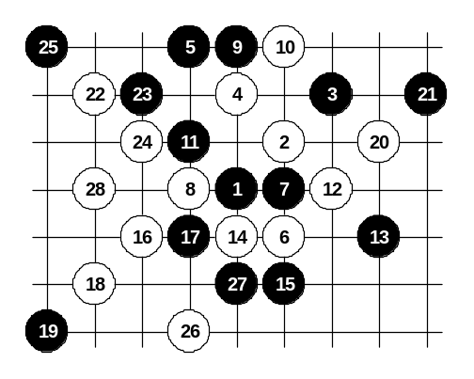

Diagram i1-84

This is the third choice of 12th move. It has been deeply investigated in the past. Move 13-13 loses, no matter how black defends.
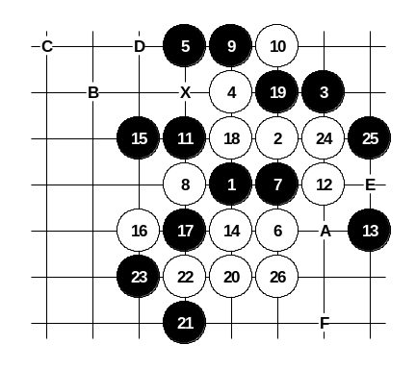

Another 15th move, but also useless because white wins directly here.

Diagram i1-85
If 15-20 then 16-16, 17-A, 18-B, 19-C, 20-D.
If 15-17 then 16-25, 17-20, 18-26, 19-15 (otherwise point X will be a 3x3), 20-A, 21-24, 22-E.
If 15-16 then 16-F, 17-26, 18-21.
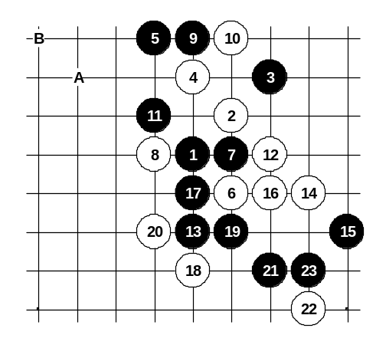

Diagram i1-86
This is the correct 13th move. The outcome of this variant is quite equal. Also possible 14-17, 15-16, 16-A, 17-B.
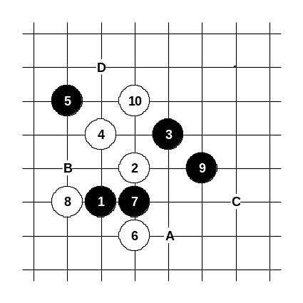
The conclusion about this 9th move: Although black has a variety of different defense styles and patterns, white always gets satisfying advantage or sometimes even wins.

Diagram i1-87
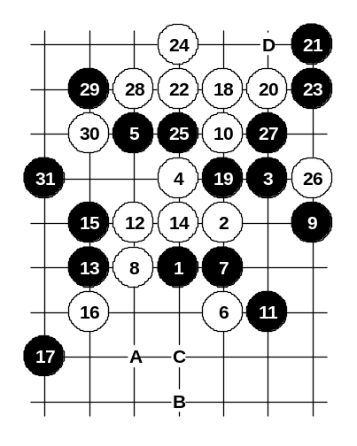
The last 9th move. This is the best 9th move. In most cases black can offer very good resistance, besides, there are lots of traps where one careless white move will lead instant white loss. This 9th move was the most widely played variant of i1 opening over 10 years ago. Several renju books and game databases offer lots of variants about it. In this book, I discuss only the most important ideas and developments. Move 10-10 is forced, otherwise black wins (for example, if 10-C then 11-D). In the following diagrams the moves 11-A and 11-B are discussed.

Diagram i1-88

Move 11-11 is an old gambling move. There are dozens of games in renju history where white failed to find the win.
This diagram shows the correct way to white victory. If 23-28 then 24-25, 26-D.
If 17-19 then white attack continues with moves to A, B, 17 and C.

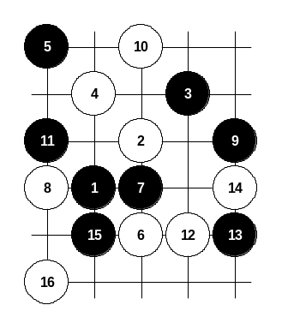

Diagram i1-89

This 11th move is the correct continuation. Move 12-12 is the only good move, any other 12th move would give black the advantage (for example, if 12-15 then 13-12).
There are two kinds of 13th moves – 13-13 and 13-15. Move 13-13 is a weak move. By the 16th move white got the initiative and black did not have any chance to develop in upper area.
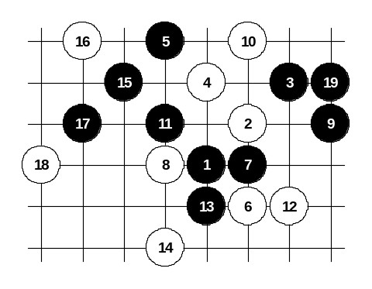

Diagram i1-90

This 13th move is quite good. White cannot take the initiative easily here.
The passive 14th move in this diagram gives black win.
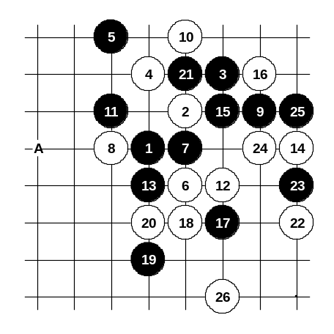

Diagram i1-91

This is the best 14th move. All the moves from 4 to 14 are the best for both black and white in this opening. Move 15-15 – one of many possibilities. The following moves are all tactically interesting. Both black and white use as active defense as possible. Move 21-21 is especially beautiful – it looks useless, but in fact it is very powerful considering the possible connection at point A. However, beautiful 22-22 helps to keep the white initiative and control.
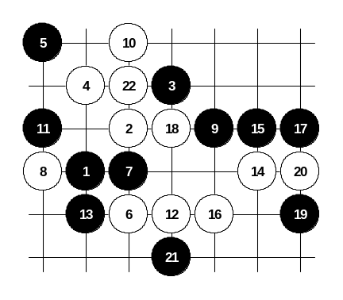

Diagram i1-92

Another 15th move. It is quite unsuccessful for black, by the 22nd move white has the whole control over the position.
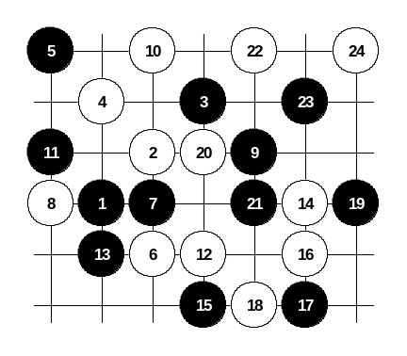

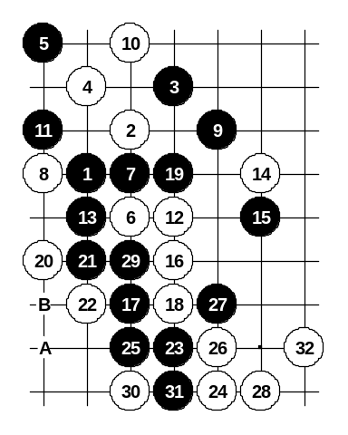
Another 15th move. The development until 21st move is very logical. White can choose between many development plans in move 22. Move 22-22 is just one example. White has the initiative and can easily control the game here.

Diagram i1-93

Diagram i1-94
Another 15th move. This move has been frequently used in old tournaments, but now it is clear that white has sure advantage here.
Move 17-17 is weak. White can immediately develop very powerful attack from move 18-18.
If 25-A then 26-26.
If 19-23 then 20-20, 21-29, 22-B.
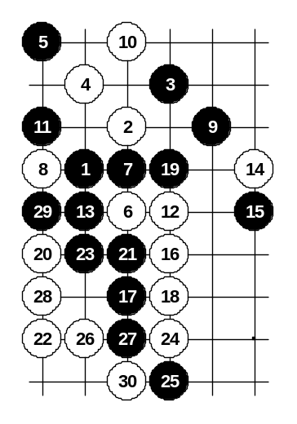

Diagram i1-95

Another 21st move. White can easily develop very powerful attack here.
Moves from 22 to 30 are just one example of white’s attack.
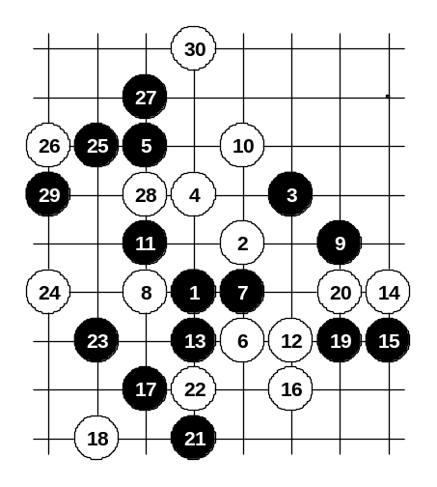

Diagram i1-96
Another 17th move. Black plays aggressively, attacking until the 25th move, and with 25-25 provokes white to counter-attack. Black’s great plan fails after passive 26-26 – white defends calmly and gets positional advantage all over the board.
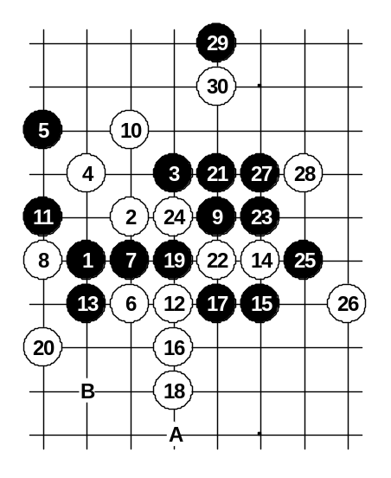

Diagram i1-97

Another 17th move. White chooses an active style and gives up the initiative temporarily. By the 30th move black counter-attack fails and white advantage in lower side is big enough to win. However, before using this risky 18th move, the player is recommended to do additional home analysis about it, to make sure that black cannot win in any way. If 19-A then 20-24, 22-B.
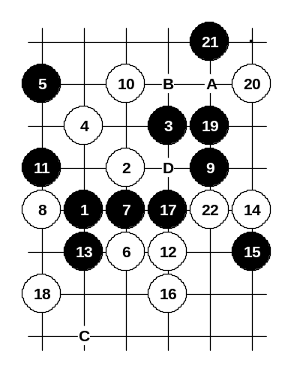
It is also possible to play safely 18-22.

Diagram i1-98

Another 17th move.
As usually, both black and white are very aggressive, however, after 22-22 white finally gets the control over the position.
Move 22-A is not good because of 23-B.
It is also possible 18-C, 19-19, 20-D.

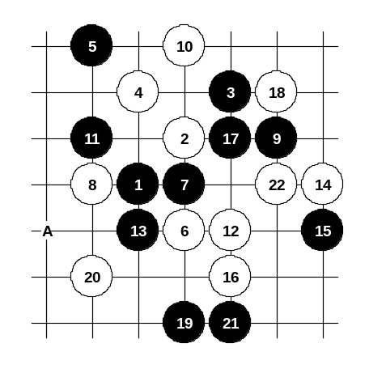

Diagram i1-99

Another 17th move.
This time black cannot create any serious counter-attack and therefore white gets the initiative easily.
If 19-20, 21-19 then 22-A.

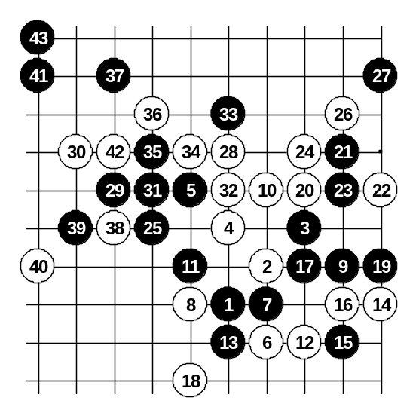

Diagram i1-100
This 15th move is the strongest. Among all the variants of this 5th move, only 15-15 can create satisfying structures for black. It is not easy to prove white advantage here. Moves 17-17 and 19-19 are the best choices for black.
The variant until 43rd move is an old famous trap of i1 opening. From move 29-29 black begins sure win attack. In order to defend, white has to change the 28th move.
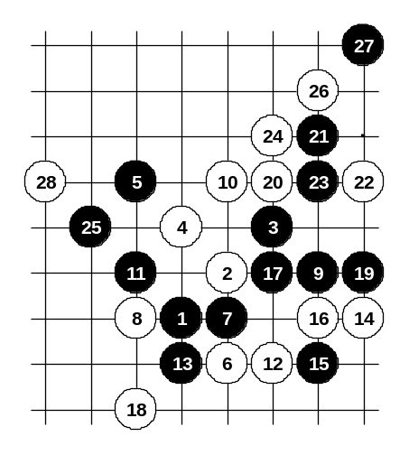

Diagram i1-101

Here white can defend the black attack. Although black still has several tactical possibilities to continue attack, it will fail sooner or later and white will get the desired advantage at some point in the future.

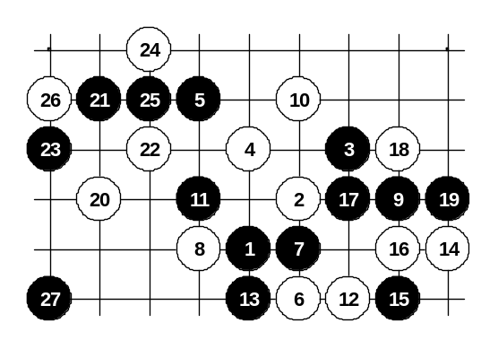

Diagram i1-102

This 18th move is not that good because it lets black control the space and key points. Black develops softly in positional style here.

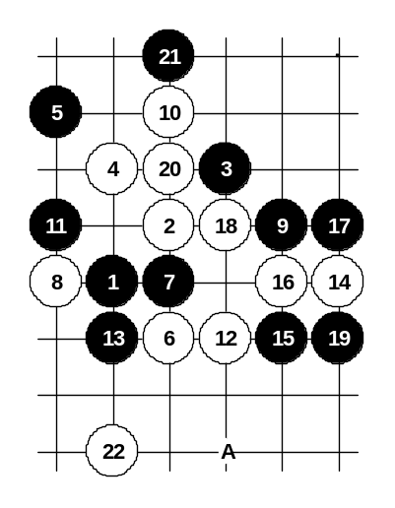

Another 17th move. It white gives immediately big advantage. If 19-20 then 20-A.

Diagram i1-103

The conclusion about this 9th move: It is the strongest possible 9th move. White has to be very careful here or otherwise black might get winning counter-attack. However, if white follows the best development plans then sooner or later white always gets the initiative.
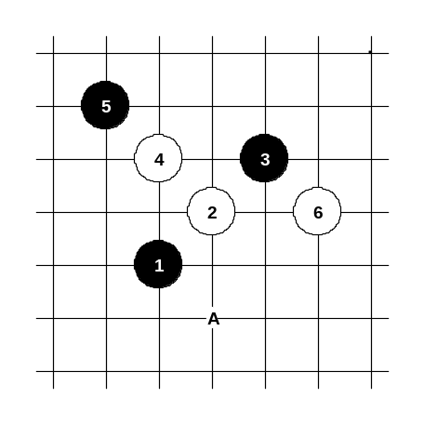

Diagram i1-104

Beginning from this diagram, the variants of rotated 6th move are discussed. Although this 6th move is similar to 6-A, the board edge’s closeness influences the evaluation of this 6th move a lot. Black advantage here is very convincing, therefore this 6th move is seldom played in serious tournaments.
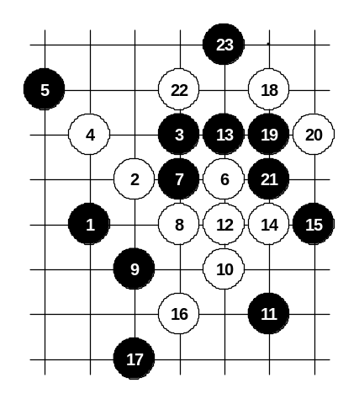

Diagram i1-105
The first choice of 8th move.
Black cannot play here as in diagram i1-65 because black attacking power would be too near to the right edge and white could win in upper side. However, moves 19-19, 21-21, 23-23 are very effective – they neutralize white attacking material and the left side’s space looks promising for black.
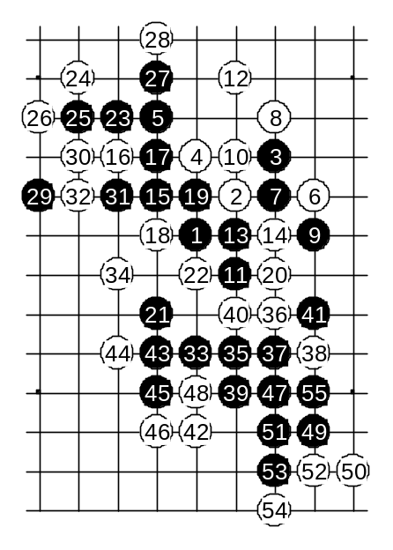

Diagram i1-106

Another 8th move. White chooses the same plan as in diagram i1-71. Because of sufficient space, black wins here. The following diagrams of this variant are shown without additional commentaries. Black attack is long, but still very confident and logical.

Diagram i1-107

Diagram i1-108
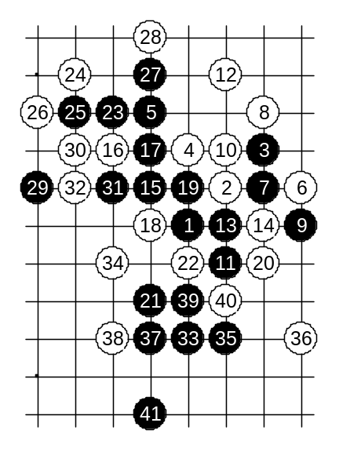
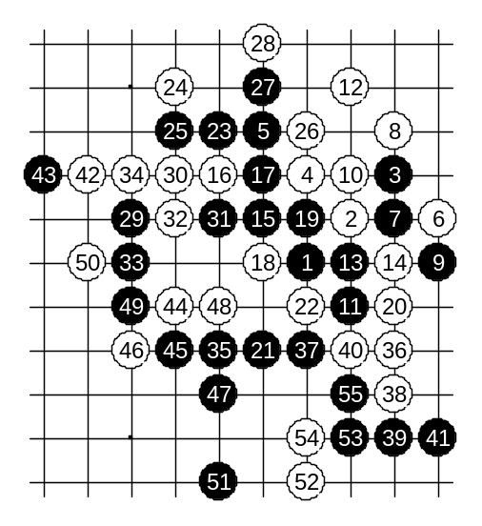

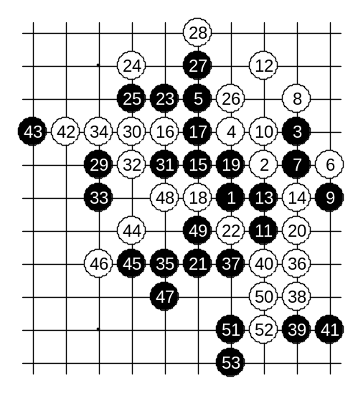
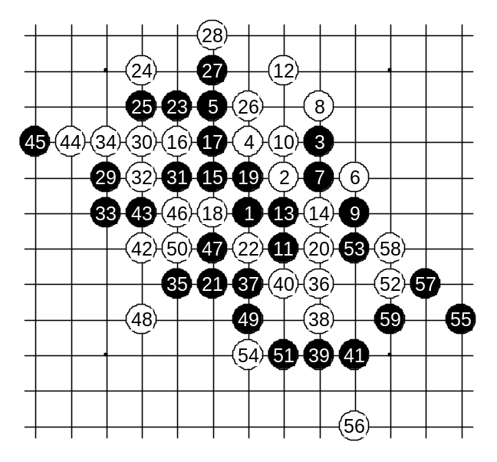

Diagram i1-110

Diagram i1-109

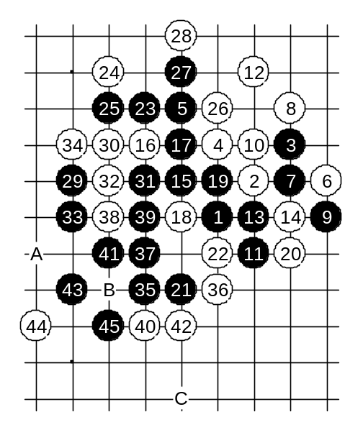

Diagram i1-111

If 38-39, 40-38 then 41-45, 43-43, 44-A, 45-B, 47-C.

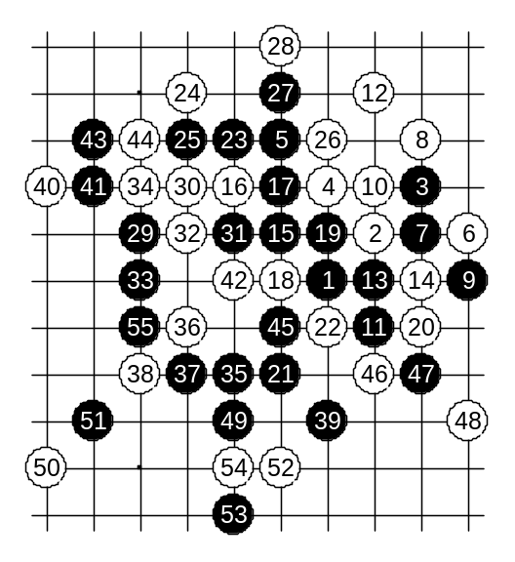

Diagram i1-112

Diagram i1-113

Another 12th move.
Black wins easily here.
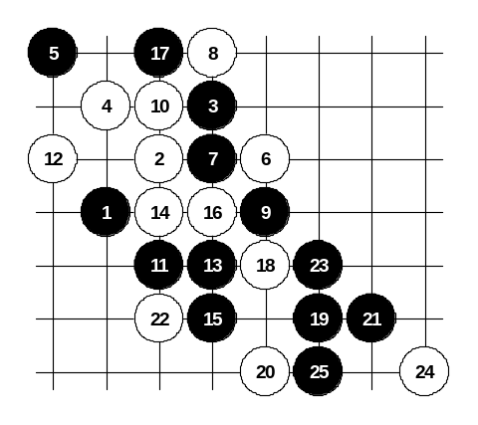

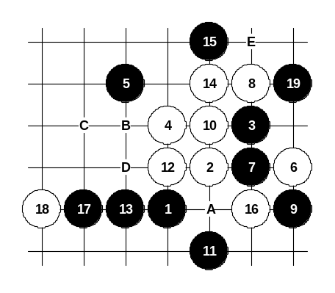

Diagram i1-114
Another 12th move. White gets a temporary initiative here. But black is about to surround white stones and after that black has satisfying advantage. If 16-A then 17-B or 17-C, 18-D, 19-E.
If 14-A then 15-14 or 15-15.
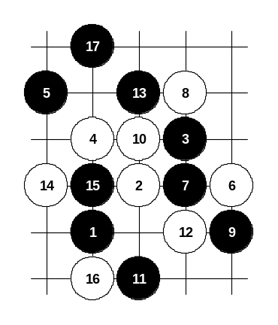

Diagram i1-115

Another 12th move. Although it is passive, it is one of the best resistance. Black gets a positional advantage, but it is not easy to prove black win here.

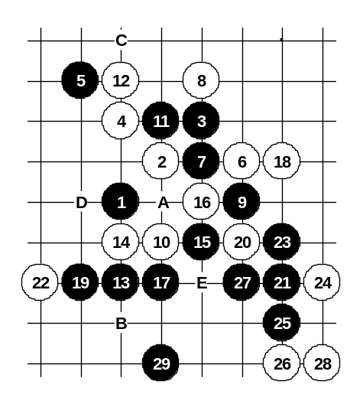

Diagram i1-116

Another 10th move. Moves 11-11 and 13-13 are probably the best development for black.
Beginning from move 15 black has a sure win attack.
If 14-15 then 15-D.
If 12-23 then 13-16, 14-A, 15-15, 17-17, 18-B, 19-C (black gets good positional advantage).
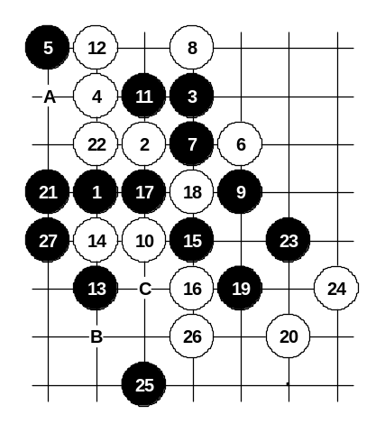

Diagram i1-117

Black win after such 16th move is not easy. Playing any four or three in wrong sequence might lead to the failure of the attack.
If 22-A then 23-B, 24-C, 25-23, 27-26.

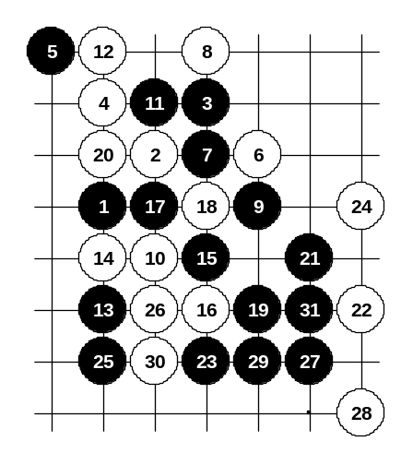

Diagram i1-118

Another 20th move in this diagram does not help either, black still wins quite easily.

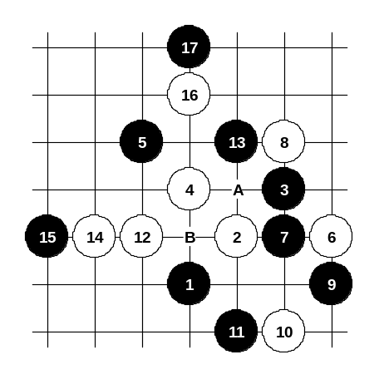

Diagram i1-119

Probably the strongest 10th move. Black has a variety of possible developments. The development on the current diagram is just one of the examples. Black has an advantage here, but in case of careful defense moves, white might be able to defend here. If 14-A then 15-B.

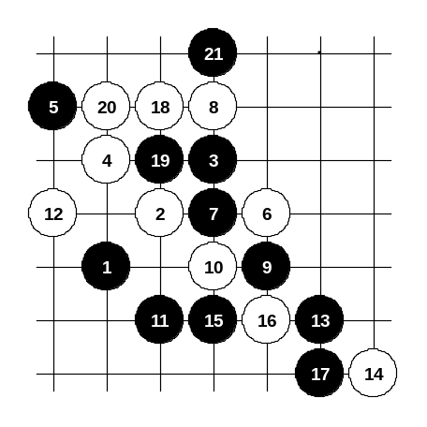

Diagram i1-120

The last choice of 10th move. After 12-12 black has an interesting development idea that ends in move 21 – black gives up the tempo, but white cannot attack because all white possible attacking structures are controlled by black.
If 12-19 then look at the diagram i1-115.

